Over here we shall get started with knowing how to get a digital reading from any of the 8 channels present.
Starting with the basic lets have a look at the features of the ADC
â€¢ 10-bit resolution
â€¢ 8 channel
â€¢ Adjustable reference voltage
â€¢ Gain adjustment
Some basic guidelines for using the ADC.
-Connect AVCC +5V.
-Connect a .22 micro farad capacitor from AVCC pin to the ground
-We have an option of using an external or internal reference voltage. If using external reference voltage, then it has to be applied at the AREF pin.
Letâ€™s define our task here:
â€˜Convert an analog voltage applied to an ADC channel to digital formâ€™
To do this we need to
- Initialize the ADC according to our requirements,
- Start the conversion
- Read the digital value
The result of the ADC conversion is stored in the ADCH and ADCL registers. A 10-bit conversion result is stored as shown.
ADCH |  |  |  |  |  |  | Bit 9 | Bit 8
ADCL | Bit 7 | Bit 6 | Bit 5 | Bit 4 | Bit 3 | Bit 2 | Bit 1 | Bit 0
To initialize we will set the appropriate registers starting from the ADMUX register.
The ADMUX looks like this.

7 | 6 | 5 | 4 | 3 | 2 | 1 | 0
REFS1 | REFS0 | ADLAR | MUX4 | MUX3 | MUX2 | MUX1 | MUX0
REFS1 and REFS0 help us to set the voltage reference source. We have options of using the following voltage references
1. Voltage at AREF pin (REFS1=0 & REFS0=0)
2. AVCC as the reference pin (REFS1=0 & REFS0=1)
3. Internal 2.56 Voltage reference (REFS1=1 & REFS0=1)
For our purpose we shall set it as 00 where AREF is at 5V.
ADLAR bit when set gives us a left adjusted result i.e. we get only the highest 8 bits of the conversion
ADLAR=1
ADCH | Bit 9 | Bit 8 | Bit 7 | Bit 6 | Bit 5 | Bit 4 | Bit 3 | Bit 2
ADCL | Bit 1 | Bit 0
ADLAR=0
ADCH |  |  |  |  |  |  | Bit 9 | Bit 8
ADCL | Bit 7 | Bit 6 | Bit 5 | Bit 4 | Bit 3 | Bit 2 | Bit 1 | Bit 0
We set ADLAR bit as 8 bit resolution is good enough for most purposes. And if we were to use all the 10 bits we would have to read 2 registers which would take more time and make the program lengthier.
For complete settings of the MUX4â€¦0 pins refer the datasheet. For our purpose we shall use the ADC7 channel (PortA 7) in single ended mode with gain 1.
So we set MUX4â€¦0 as 00111
Next we take on the ADCSRA register.
7 | 6 | 5 | 4 | 3 | 2 | 1 | 0
ADEN | ADSC | ADATE | ADIF | ADIE | ADPS2 | ADPS1 | ADPS0
Set the ADEN bit to enable the ADC. ADIF is the ADC interrupt flag which is set when ADC conversion is complete and ADIE (ADC interrupt enable is set).
The ADSC bit is used to start conversion.
The ADATE along with the ADTS2â€¦0 (in SFIOR register) is used to select the trigger source to start ADC conversion. Since we will be using ADSC to start conversion we donâ€™t need any other trigger so we keep ADATE=0 and ADTS2â€¦0 =000
ADPS2â€¦0 is used to set the prescaler for the ADC clock. The ADC needs a clock frequency between 50kHz to 200kHz.
If we are using a 16MHz crystal we shall set ADPS2â€¦0 = 111 so that will give us a prescaler of 128 and therefore set the ADC clock to 125kHz. (16M/128 = 128k)
Enough of theory. Lets implement this using a C program.
Development tools used:
Software - ICC AVR
Hardware - Micromouse Develoment board from TRI
A simple hardware setup for using this program is as follows.
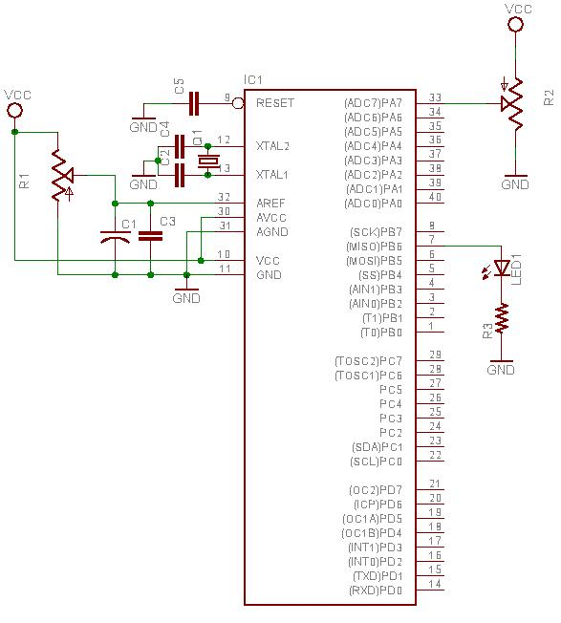
R1,R2=10kOhm variable resistor
R3=1kOhm
C1=10 micro farad electrolytic
C2,C4=15 pico farad
C3=0.1 micro farad
C5=0.1 micro farad
Q1=16Mhz crystal
#include<iom16v.h>
#include<macros.h>
#define CHECKBIT(x,b) x&b
#define SETBIT(x,b) x|=b;
#define CLEARBIT(x,b) x&=~b;
#define TOGGLEBIT(x,b) x^=b;
#pragma interrupt_handler adc_interrupt:15
void delay(unsigned char time) //Function to generate time delay
{
for(l=0;l<TIME;L++)
{
for(m=0;m<10000;m++)
{};
}
}
void adc_interrupt(void) //ADC interrupt routine
{
unsigned char digital=0;
digital=ADCH; //Store contents of ADCH in variable
SETBIT(PORTB,BIT(6)); //Turn on LED connected to PortB6
delay(digital); //Delay proportional to analog voltage
CLEARBIT(PORTB,BIT(6)); //Turn off LED connected to PortB6
delay(digital);
SETBIT(ADCSRA,BIT(6)); //ADC start conversion
}
void adc_init(void) //Interrupt initialisation
{
ADMUX=0x27; //ADC7, Left adjust,AVCC reference voltage
ADCSRA=0x8F; //Enable ADC, ADC interrupt, prescaler 128
}
void main(void)
{
adc_init();
DDRB=0xff; //Set PortB as output port
SEI();
SETBIT(ADCSRA,BIT(6)); //ADC start conversion
while(1){}
}
What does the program do??
If your answer is the time delay for blink is proportional to the analog voltage applied then you are right ïŠ
Ref – http://www.thinklabs.in

